**Date: 9/29/2019**

**DMDD Assignment 3 (SQL Queries)**

1. Query 1: List the titles in order of total sale. Totals sales is determined by reading the qty from sales and calculating the sales price based on the price of the book in the titles table

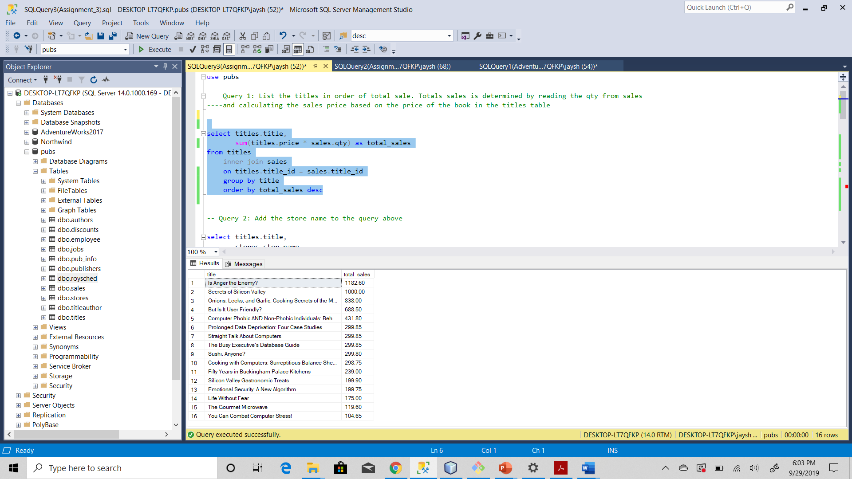

1. Query 2: Add the store name to the query above

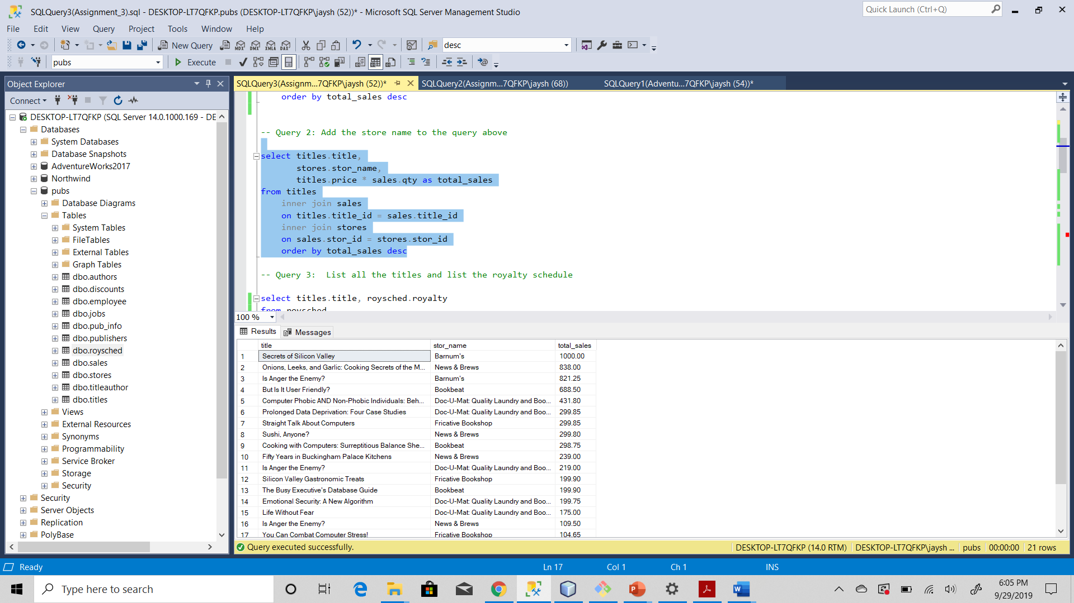

1. Query 3: List all the titles and list the royalty schedule

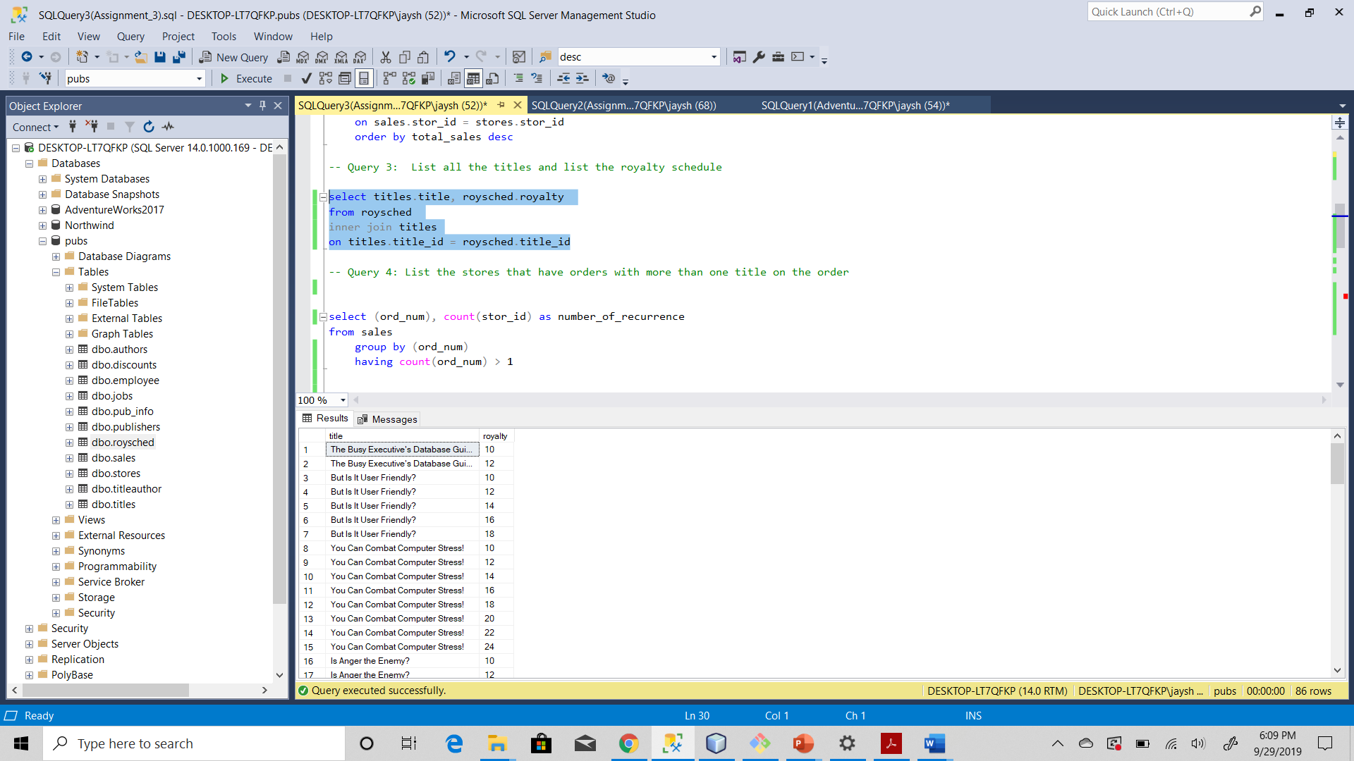

1. Query 4: List the stores that have orders with more than one title on the order

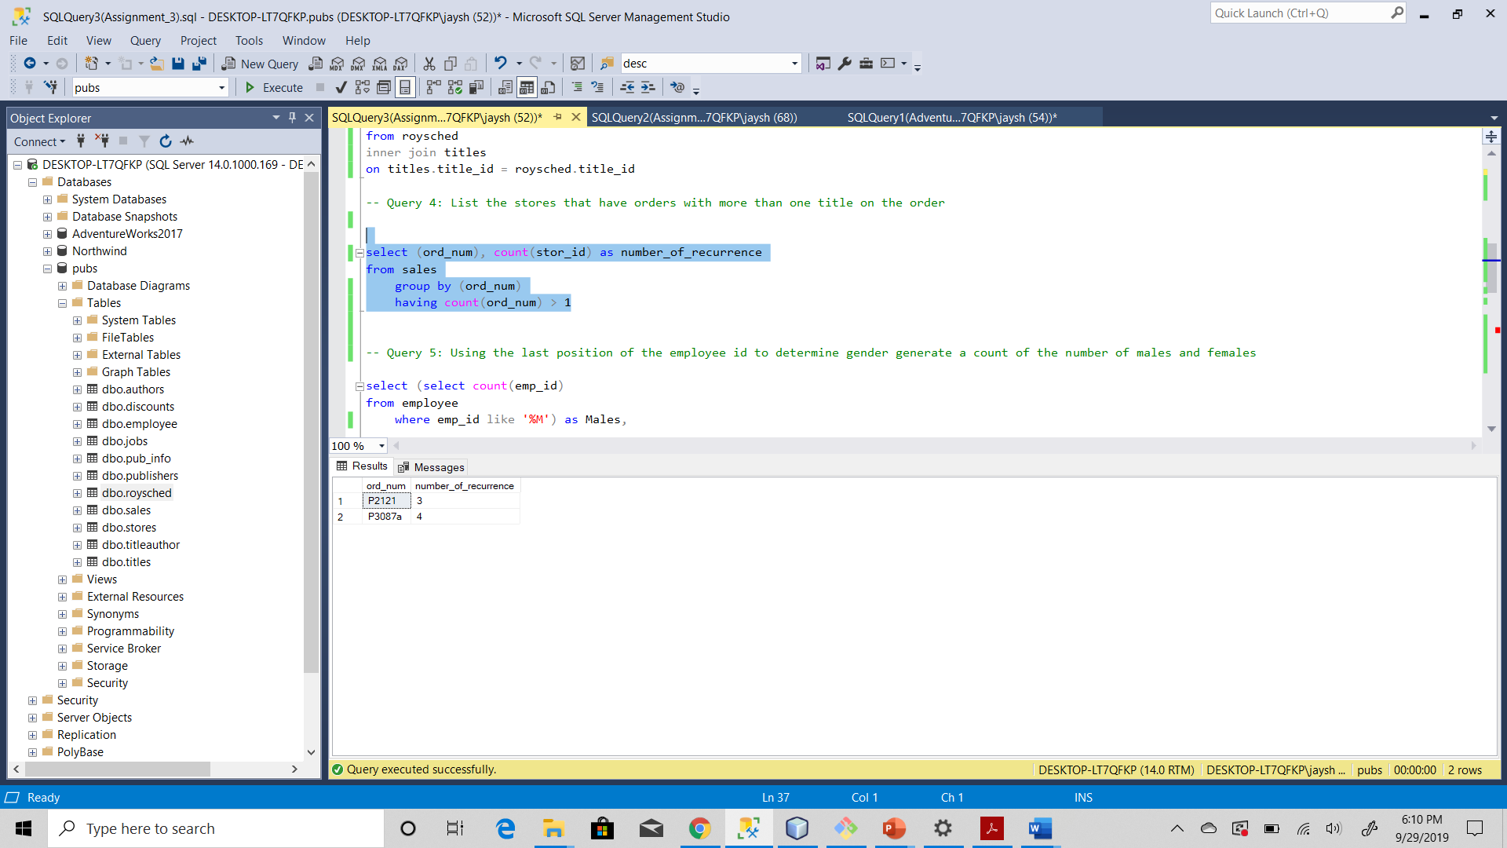

1. Query 5: Using the last position of the employee id to determine gender generate a count of the number of males and females

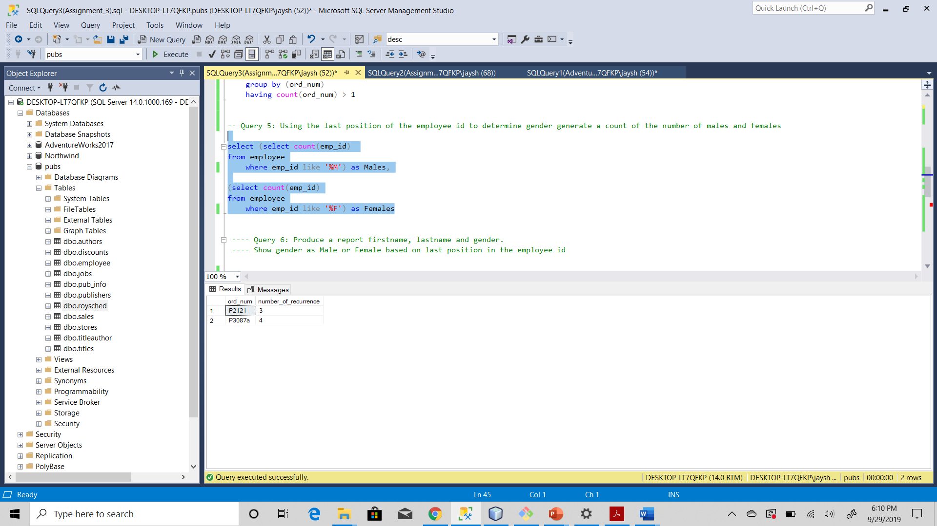

1. Query 6: Produce a report firstname, lastname and gender.  Show gender as Male or Female based on last position in the employee id

